Die Antwoord: The Face of a Homologous Subculture, or a Purposeless Façade of Zef?
Julia Engel
English, Italian, and Social Policy & Practice BA Candidate 2017
English MA Candidate 2018
Tulane University
Jengel@tulane.edu
30 May 2017

In his work “Subculture: The Meaning of Style,” Dick Hebdige creates a working definition of the highly debated term ‘subculture,’ which he uses to analyze the British punk movement of the 1970s. In his highly logical, evidence-based classification of subculture, Hebdige requires that, in creating its rebellious “forms and rituals,” that clash so harshly with mass culture, a subcultural group must attempt to create an identity with the following: “the status and meaning of revolt, the idea of style as a form of Refusal, [and] the elevation of crime into art” (Hebdige 1259, 1258). In this essay, I will analyze whether the South African rap-rave musical group Die Antwoord, which claims to be a part of the Zef subcultural music movement, fits within Hebdige’s definition of subculture—or, if Die Antwoord’s Zef style is simply meaningless “graffiti” strewn across the walls of South African history (Hebdige 1259). While the band does in many ways mirror the tendencies of 1970s punk, I argue that there are a number of key differences which ultimately place Die Antwoord more comfortably into the category of mass popular culture. I will start by explaining the merits of Hebdige’s definition of subculture, using this to compare Die Antwoord and convey the flaws in its attempt to represent the subculture of Zef.
According to Hebdige, the birth of a subculture must start with a crime against the mainstream culture, and end “in the construction of style, in a gesture of defiance and contempt” whose otherness possesses a specific significance, or meaning (1259). Hebdige emphasizes quite heavily the use of quotidian material objects as a means of creating an evocative subcultural style. Hebdige calls upon the example of punks, who utilized everyday household objects in their garish ensembles— lavatory chains, plastic bin-liners and safety pins were “taken out of their domestic ‘utility’ context and worn as gruesome ornaments” (Hebdige 1260). In their re-assemblage of everyday objects into extreme statements of contempt for mass culture and its authority over society, the punks were able to create a visual identity in such rejection. As a result, the punks were largely vetoed and spurned for their rebellion by older generations of Brits, while simultaneously being “canonized” by mainstream British media; they were seen at times as something to fear as they had the potential to destruct the “public order,” and at other points in time as inconsequential jokesters (Hebdige 1259). Thus, in offending the public, a subculture digs a niche location in that society for itself: “So the tensions between dominant and subordinate groups can be found reflected in the surfaces of subculture—in the styles made up of mundane objects which have a double meaning” (Hebdige 1259). In fact, I assert that Hebdige’s emphasis on the point that subculture must possess the power to scar and deface the dominant culture from which it stems, as punk did, is the most important aspect of his definition (1259).
As Hebdige demonstrates, punk subculture was able to disfigure British popular culture in numerous ways. Using “confrontation dressing,” or the use of normal objects and the reconstruction of unassuming materials such as PVC and lurex, the use of female cosmetics for both men and women in garish fashions, extreme-colored hair and Mohawks, and the redefinition of school uniforms, punks aimed to create their own social “commentary” on what the concepts of “modernity and taste” should be, as well as what the definition of beauty should look like in mass culture (Hebdige 1260). In this display, the punk subculture destabilized the dialogues being put forth in the media on what it meant to be tasteful and beautiful, and what modern society attempted to define itself as. Punk style also put the sexually fetishized on display for the world to comment on: “Rapist masks and rubber wear, leather bodices and fishnet stockings… the whole paraphernalia of bondage… were exhumed from the boudoir, closet and the pornographic film and placed on the street where they retained their forbidden connotations” (Hebdige 1260). Punk brought the underlying sexuality that British pop culture attempted to smother into the public sphere, where its existence and prevalence could no longer be denied. Seeking reactions of disgust and anger from the average Brit, punks voluntarily exiled themselves as outcasts of society, which in turn defined the entire punk subcultural movement (Hebdige 1261). To have the ability to publically call into question the ethics of the mass culture from which a subcultural group stems in such a way that outliers from the subculture also begin to question it is a significant feat, and arguably the most definitive indicator of a successful revolt. This point is one of the key reasons that I have chosen to utilize Hebdige’s definition of subculture to analyze the authenticity of Die Antwoord.
Another key reason that Hebdige’s definition is so complimentary to this discussion of Die Antwoord’s failure to exemplify the Zef subculture is its emphasis on the relationship between revolt, art, and the lower class. As Hebdige demonstrates, punk was a movement focused on mass culture’s manipulation of the working-class. Punk music, in its deliberate unmelodic tones and amateurish sound, posed a direct attack against the “bourgeois notion of entertainment or the classical concept of ‘high art’” which excluded the working-class and made them a group of outside onlookers to an impenetrable form of art that was meant to be idealized (Hebdige 1261). Through live performances, punk bands such as the Sex Pistols, the Clash, and the Rejects instead sought to connect directly with audiences, merging the gap between performer and spectator. In allowing fans of all socioeconomic statuses to make “the symbolic crossing from the dance floor to the stage,” and with band members engaging in mosh pits and the mutual destruction of both venue and instrument during live shows, punk bands rejected the traditional idea that audience and performer must be physically separated by means of a stage and theater seats (Hebdige 1262). No longer was art an unattainable concept to be idealized and aspired to, but something that could be interacted with, destructed, and manipulated as punk audiences crowded concert halls for these havoc-reeking shows.
In the rebellious cheap production of fanzines by working-class punks, the subculture once again was able to take the power of critique out of the hands of commercial media entities. These fanzines tended to include manifestos that were often identifiable in their language as being of working class origin, with their use of swear words and a refusal to correct typos and misspellings, even in final edits (Hebdige 1262). This group of working-class punks demonstrated a thriving dedication to the subculture; it was this subset in particular who took up the term “punk” as a mark of self-identity, reveling in its connotation for worthlessness, meanness, and trifling treachery (Hebdige 1263).
Like punk, the Zef movement that Die Antwoord identifies with has been largely defined by its glorification of the grungy, unkempt undertones in its name, as it is the derogatory identifier for South Africa’s white lower-middle working-class. According to scholar Anton Krueger, “Zef denotes a particular style of vulgar humour which has been emerging more and more in South Africa during the past decade,” that is constructed by “presenting a persona in a purposefully degrading way, exaggerating one’s appearance and mannerisms as low class, ill-bred, and boorish” (158). Yet this subcultural repossession of an offensive name for poor white South Africans is a fairly new phenomenon—the word “Zef” has deeper historical roots tied steadfastly to the South African apartheid.
This new countercultural redefinition of Zef is one that has evolved from a turbulent colonial history in South Africa. Historically, Zef is a subgroup within the Afrikaner (also called Afrikaans) subgroup of South Africa, or “the ethnic, white culture forged by the Great Trek (1835-1846)” of Dutch colonists to southern Africa (Krueger 160). As the creolistic formation of the Dutch settlers fought against both indigenous African groups and the British over 300 years to sustain their place in the southern region of the continent, the Afrikaners became the dominant population in South Africa when it was established as a union in 1910 (Climent, Hill, Macmichael, Skutsch 1156). The group rose to their peak of power in 1948 with the creation of the Afrikaner-based National Party, responsible for the implementation of the apartheid. Afrikaners remained in power throughout the century, eventually developing South Africa into a Republic in 1960 (Climent, Hill, Macmichael, Skutsch 1156).
Thus, “The ideologues responsible for the construction of hegemonic Afrikaner identity during the era that saw the rise (and fall) of apartheid, did so by painstakingly weaving Afrikaner nationalist ideology into the fabric of Afrikaner society,” specifically through Afrikaner music (Van Der Merwe 349). And as Afrikaners solidified themselves within South Africa, class divisions within the group itself grew more pronounced—with lower, middle, and upper segments developing and becoming highly concrete (Climent, Hill, Macmichael, Skutsch 1156). As the most vulnerable group of Afrikaners, the lower class became an easy scapegoat for middle and upper-class Afrikaners to place the fault and shame of the apartheid upon after the fall of the National Party.
The term ‘Zef’ was coined in 1960s and 1970s South Africa for lower-middle class working Afrikaners, especially in the West and East Rand of Johannesburg; it refers to the Ford Zephyr model, a common car used by white working-class taxi drivers in these decades (Klopper). Middle and upper class Afrikaners derogatorily referred to owners of Ford Zephyrs as being ‘Zef.’ Zef culture therefore specifically has a link to the “lineage of white poverty,” experienced by lower class Afrikaners, and is tied directly with the “disgrace experienced by many white Afrikaner people after apartheid” (Krueger 158). “The inheritance of the present generation of Afrikaners… is largely one of shame” as they experience the reverberations of the brutality their ancestors inflicted upon native South Africans as well as other non-white migrants who had sought refuge in South Africa; this shame has largely been forcefully placed onto the shoulders of lower class Afrikaners, as they are the most vulnerable Afrikaner subgroup (Krueger 159). In recent decades, however, lower-middle class white South Africans have taken the term Zef as their own and used it as a prideful symbol of identity amongst the highly variant ethnic landscape in South Africa. The term ‘Zef’ has now been transformed from a derogatory term used against poor South Africans of Afrikaner descent into a phrase of pride used by the group themselves.
The sense of embarrassment and flip of power in the aftermath of apartheid has been embodied in current Zef culture as it has fought to reconcile with the “hegemonic Afrikaner identity” that had solidified itself with the “hardening of apartheid,” in particular through its means of dress and its unique style of music (Van Der Merwe 350). ¥o-landi Vi$$er, the lead female singer of Die Antwoord, has been quoted saying that Zef is “associated with people who soup their cars up and rock gold and shit. Zef is, you’re poor but you’re fancy. You’re poor but you’re sexy, you’ve got style” (Hoby). In its relationship to the working-class, the Zef movement therefore embodies a commonality between itself and punk subculture. Ninja, the rap component of Die Antwoord, says “Zef is South African underdog kind of style,” noting that it has historically been a word of insult “for [a] long [time] in South Africa,” but that “the word kind of started transforming about 10 years ago” (Mechanic). Now, with its reformed identity, “Zef is the underbelly of the Afrikaans culture, but it also, like, is Afrikaans culture,” according to Ninja (Mechanic). Thus, the actual movement of Zef can definitively be argued as subcultural—the issue at play is instead whether Die Antwoord can be argued as an authentic representation of Zef subculture.
This matter is a complicated one, as Die Antwoord does fulfill Hebdige’s definition of subculture in many ways. For instance, as the self-identified face of Zef music, Die Antwoord has logically chosen the Ford Zephyr as its object of choice as a symbol to represent themselves with. In virtually every music video, blinged-out, graffiti-ridden Ford Zephyrs flash across the screen. In the music video for “Baby’s on Fire,” a Zephyr is driven in violent circles around ¥o-landi Vi$$er, as she dances euphorically in a sand lot surrounded by sun-bleached pastel apartment buildings.
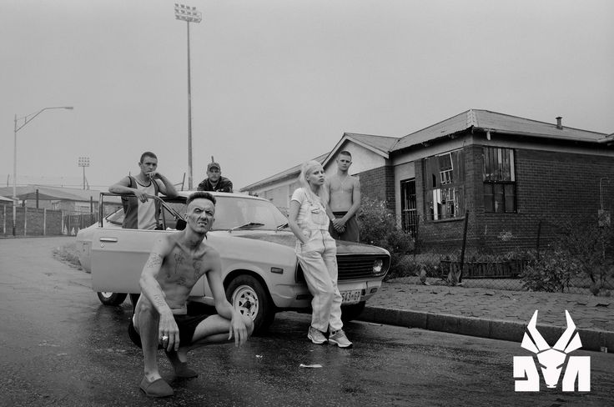
The additional presence of graffiti, the “Zef” logo emblazoned on their clothing, bright colors, gaudy jewelry, the use of Afrikaans language, and the overt use of a lower middle-class urban environment in its music videos, posters, and album artwork are all symbols of the Zef lifestyle that Die Antwoord intentionally places within its work, as well as weaves into its live shows and merchandise. Thus, Die Antwoord’s manipulation of environment and use of unique clothing, hair, and accessories is a direct attempt at creating a homologous style, a requirement of subculture for Hebdige. Hebdige defines the term “homology” as “the symbolic fit between the values and lifestyles of a group, its subjective experience and the musical forms it uses to express or reinforce its focal concerns” which make up a “whole way of life”; in a 2011 interview, Ninja states rather explicitly that “Zef in South Africa is like a whole style. It’s like a way of thinking, and dressing, and how things sound and stuff” (Hebdige 1263; “Die Antwoord Extended Uncut Interview”). Die Antwoord’s commitment to being the face of Zef music is therefore a statement of being committed to the “Zef way of life.”
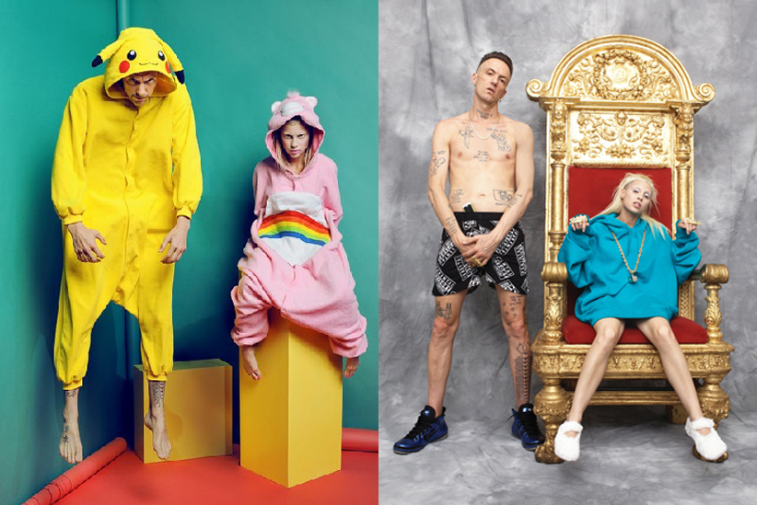
Much like the reaction of dismissal and denunciation of many older Brits of the 1970s of punk music and punk style, Ninja states that “a lot of the older [South African] people were like, ‘Jesus, this is fokken terrible—like the worst representation of South Africa ever’” (Mechanic). This statement indicates that there has been apparent opposition to the Zef representation of South Africa, and a refutation of it embodying multiple layers of the country’s culture from older and more traditionalist parties. In response to receiving vocal rejection by older generations of Afrikaners to the Zef culture they identify with, Die Antwoord has in some regard carved out a counter-culture that stands strongly in opposition to more central currents of South African culture. Die Antwoord has, at least on a minimal level, therefore possessed “the power to disfigure” South African popular culture in its representation of Zef (Hebdige 1259).
What must be assessed, then, is if there is a purpose to this disfiguration; does Die Antwoord have a social agenda underlying its rebellious song lyrics, its kitschy style, and its confrontational music videos, or is it an attempt to push social limits simply for the sake of it? Two key methods of forming such deviance from the norm of popular culture that Hebdige cites are social and sexual, which like much of punk artistry, Die Antwoord’s music—and especially its music videos—are able to “give an impression of multiple warping which was guaranteed to disconcert the most liberal of observers” (Hebdige 1265). In the band’s ability to create controversial social and sexual dynamics in its music videos, Die Antwoord has certainly proved its power to rebel against the portrayal of sexuality that popular culture propagates.
In the video for “I Fink U Freaky,” Die Antwoord members ¥o-landi Vi$$er and Ninja can be seen in a dark, grungy, creepy environment acting in overtly sexual manners while repeating the words “I fink you’re freaky and I like you a lot” ominously throughout the video. With its use of animals not commonly found in the music videos of the average pop star—such as ducks, weasels, and a white rat—and its scenes of ¥o-landi being grabbed by bodiless hands layered on grafittied mattresses and bathing seductively in a tub filled with black, tar-like water, the obvious aim of the video is to make the viewer uncomfortable with its interpretation of sexuality. Yet, I would argue that this work is merely pushing the limits of tolerance for the strange and fetishized in the media merely for the shock-value, rather than creating a level of discomfort meant to force the viewer to question why certain taboos surrounding sexuality in the media are present and consequently rejecting such censorship. There is no indication in the video itself that Die Antwoord is intending to create a political or social commentary with the work—rather, it is meant to entertain the viewer in its audacious strangeness. The song’s lyrics are also deeply disconnected from the theme of ‘freakiness’ that the video promotes, even giving product placement to Dr. Dre Beats headphones:
“Hold up!/ Whoah whoah whoah/ Wait a minute minute Jesus Christ/ Yo my man DJ Hi-Tek,/ Shit this motherfucking beat is nice/ Back in the day them wankies/ Didn’t wanna believe in us/ Little did they know that they was in for a mutherfucker big surprise/
Left on, locked in my Zef Zone/ Ready for the diss, yo?/ Motherfucker guess so/
Overseas when the fucking heads get blown/ When everything will seem like
Dr. Dre Beats headphones/ When I get home I lounge on my Zef throne, mate
Mom after me cause I get so great/ making my money rapping over techno rave/
I can take you underworld lets go babe/ When I step up and do my thing put you in a trance/ My Zef motherfucking clique got it going on/ Fuck what you think I do what I motherfucking want/ I can make a million little mutherfuckers jump.” (Die Antwoord “I Fink U Freaky”).

Its lack of consistency in its message conveys a dearth of commitment on the part of Die Antwoord to creating a subcultural manifesto to disseminate to its viewers— unlike the punk movement, which created its manifestos so succinctly with its fanzines and explicit song titles. While Die Antwoord’s lyrics cite ‘being Zef’ repeatedly, they fail to convey what being Zef actually entails. Combined with the overt product placement of the Dr. Dre Beats headphones in both the video and the song’s lyrics, Die Antwoord has also accepted capitalism’s presence in all forms of western culture, including art—something that a group truly in the throes of subculture would not do. I therefore conclude that Die Antwoord has failed to meet Hebdige’s definition of subculture in this regard.

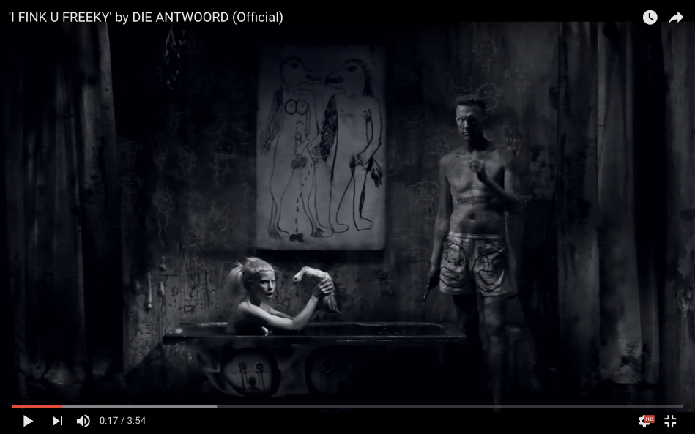
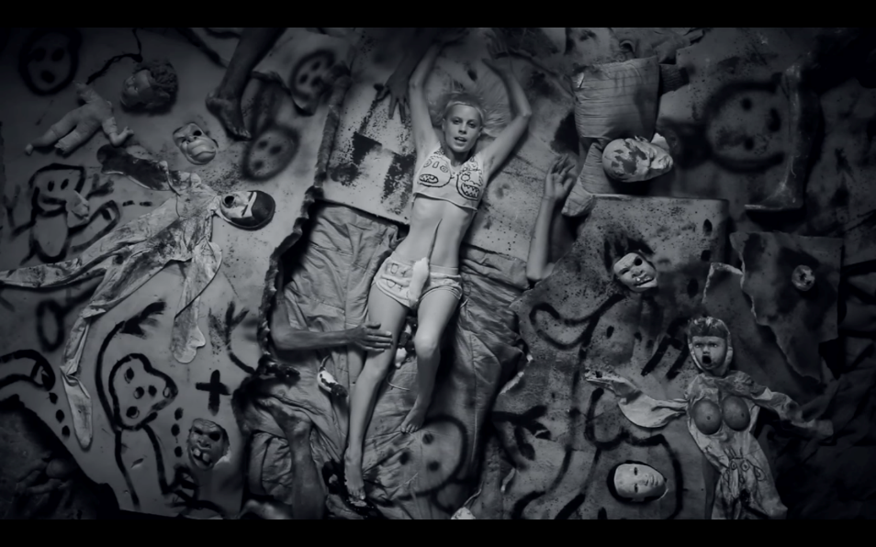
Other examples of Die Antwoord’s tip-toeing around the representation of a subculture is ¥o-landi’s defiance of authority and gratification towards forbidden sexual conquests in “Baby’s On Fire,” as well as the cinematography found in “Banana Brain,” and “Cookie Thumper.” In all three videos, there is an element of authority being broken, child-like behavior or dress being perverted into explicitly sexual images, and an obvious attempt at creating a strange environment for sexual engagement—yet no definite, concrete reason for rebellion against popular culture to be found. In the music video for “Baby’s On Fire,” Ninja plays ¥o-landi’s big brother, who throughout the video is attempting to thwart ¥o-landi’s plan to have sex with her love interest “JP.” “I don’t want that scumbag motherfucker hanging around my little sister! You hear me?” Ninja screams in the video’s introduction, “They just got one thing on their minds, you hear me? One thing” (Die Antwoord “Baby’s On Fire”). Similarly, in “Cookie Thumper” ¥o-landi can be seen sneaking out of an orphanage populated with scantily-clad adult ‘orphans’ to visit “Aines,” a black South African who has recently been released from prison. In “Banana Brain,” ¥o-landi is seen wearing a conservative dress reminiscent of that one would find on a china baby doll, and has long, platinum hair—a sharp turn towards normality from her usual partially shaved hairstyle and revealing clothing. Yet, after sneaking her parents a full bottle of sleeping pills, ¥o-landi escapes with Ninja to a Zef party where she kisses a woman and is confronted by Ninja with an enormous glow-in-the-dark strap-on. Thus, it is how ¥o-landi acts, who she is with and where she is that conveys a loss of sexual and social innocence in a way that refutes the globalized sexual ideal of the heterosexual woman found in dominant popular culture: that she is a passive object, that she does not experiment with homosexuality, that she is obedient, and that her sexuality is conveyed for the arousal and pleasure of the male viewer.
And while these portrayals of the sexual are overt strays from those found in mainstream pop music, unfortunately, yet again, there is no consistent message throughout these videos that can be identified as explicitly Zef. While the videos are racy, stylish, and outlandish, in their destruction of social and sexual norms, the group fails to convey to the viewer what the Zef alternative to popular social and sexual imagery is. Are these videos conveying that sex is a deviant and rebellious act, a journey from childhood into adulthood, or that sex is something frivolous? It is unclear if, like the punk movement, Die Antwoord is attempting to redefine the boundaries of beauty and sexuality, or if it is seeking to communicate a completely different dialogue altogether. As Hebdige iterates, a subculture must have a specific set of messages around which it forms, and a political agenda that it wishes to propel with the group’s style of dress, music, and art. While Die Antwoord says repeatedly that it is Zef in these songs’ lyrics, we are still left in the dark as to what its personal definition of Zef truly is, why Die Antwoord is worthy of being the face of Zef, and what political messages the group stands behind.
Although through my analysis it has become apparent that Die Antwoord has failed to create an explicitly subcultural identity for itself, its “Fatty Boom Boom” music video is its most blatant refutation of popular culture, and thus comes the closest to being subcultural in nature. The video is a clear rejection of the music of pop star Lady Gaga, as a result of a Twitter battle that ensued between Lady Gaga and the band.
With the release of its album Ten$ion in 2012, Die Antwoord’s international popularity began to swell (Klopper). As a result, Lady Gaga, “probably the most acclaimed international pop star,” of the time, invited Die Antwoord to perform as her opening act on her Born This Way tour—an invitation that the group aggressively refused, claiming that its ‘“Zef’ style is too ‘hardcore, like solid heavyweight’ to be associated with the ‘shitty pop music’ of Lady Gaga” (Klopper). A subsequent Twitter skirmish erupted between Die Antwoord and Lady Gaga, who slandered the group: “i fink u freaky but you don't have a hit. hundred thousand tickets sold in [South Africa]. #thatsmyshit,” tweeted Lady Gaga, riffing on Die Antwoord’s song “I Fink U Freaky.”
Die Antwoord’s music video “Fatty Boom Boom” represents a reply to Lady Gaga’s declaration of popularity, and as a result encapsulates “The status and meaning of revolt” Hebdige requires in his definition of subculture—in this case, a revolt against American pop music being the idealized goal for all artists worldwide (Hebdige 1258). In the video, Die Antwoord creates a parody of Lady Gaga, having a male actor dressing in the iconic “Meat Dress” that the artist wore to the 2010 MTV Video Music Awards. “Lady Gaga” is first seen riding unamused in a beat-up minivan receiving a ‘tour of South Africa’; the camera flashes to graffiti-riddled streets, and black South Africans mingling with wild lions, hyenas, and a black panther in what the tour guide refers to as the “concrete jungle” (Die Antwoord “Fatty Boom Boom”). The character looks on listlessly, until her tour guide comes across Die Antwoord performing in the street, to which she finally reacts, “Oh my God, look at their freaky fashion! I should get them to open for me” (Die Antwoord “Fatty Boom Boom”). After her tour van is held up by a group of gunmen, ‘Lady Gaga’ is then subjected to a traumatizing gynecologist visit in which she has an ‘exotic’ South African insect extracted from her vagina, and is ultimately mauled by a lion and killed at the end of the video. In both Ninja and ¥o-landi’s lyrics, they verbalize their rejection of Lady Gaga: “No, I do not want to stop, collaborate or listen… I’m takin’ over America, blowin’ up everything,” asserts ¥o-landi, while Ninja negatively references the American pop star’s interest in the band: “Suddenly you’re interested ‘cos we’re blowing up overseas” (Die Antwoord “Fatty Boom Boom”). Throughout the video, ¥o-landi can also be heard yelling such bellicose lyrics as, “Fight fight fight!/ Kick you in the teeth, hit you on the head with the mic” (Die Antwoord “Fatty Boom Boom”). This ‘killing off’ of Lady Gaga, as well as Die Antwoord’s aggressive lyrics, are demonstrations of an “elevation of crime into art,” one of Hebdige’s key required actions of a subculture (1258). The murder of Lady Gaga is a metaphorical representation for the homicide of pop music—in particular American pop music, which Die Antwoord believes it stands in stark opposition to. Thus, through violently killing Gaga in the end of the video while the band’s sadistic lyrics pound the viewer’s ears throughout, Die Antwoord is attempting to create a political message here regarding the sterilization of popular music, and to convey that it wants no part in the pop music regime.
However, Lady Gaga is both a fashion and a music icon that prides herself on her representation of the ‘strange.’ She has made numerous outlandish fashion statements at major music events, such as the “Meat Dress” that Die Antwoord references in its “Fatty Boom Boom” music video. Although Lady Gaga has never explicitly framed her music or her image as representations of a subculture, she has in many ways fulfilled Hebdige’s definition of subculture—possibly more so than Die Antwoord. Lady Gaga has created a distinct relationship with her fans that not many artists before her have cultivated, “built by her messages of self-acceptance and by her intense engagement with fans through social media” (Click, Lee and Willson Holladay, 360). Calling her fans her “little monsters,” Lady Gaga has stripped the word “monster” of its “negative connotations,” allowing her “fans to use her as a mirror to reflect upon and embrace their differences from mainstream culture” (Click, Lee and Willson Holladay, 360). Her fans are often unconditionally committed to the pop star; Lady Gaga’s commitment to the empowerment of her fan base has therefore created “a major dimension in people’s lives,” constructing meaning in her music and her persona (Hebdige, 1266).
Thus, can Die Antwoord truly discount Lady Gaga as not being subcultural? The group has only referenced the fact that Lady Gaga’s music falls within the pop genre, and their opinion of it being poorly crafted as reasons negating her subcultural potential: Ninja has claimed that “Pop music started getting fokken dumb—like the-retards-are-winning type style” (Mechanic). In critiquing her popularity, Vi$$er and Ninja view Gaga as lacking originality and authenticity. Yet Die Antwoord themselves is growing more popular; calling Lady Gaga out for her success is therefore highly hypocritical. On YouTube, “Fatty Boom Boom” has over 31,978,000 views; “Baby’s On Fire” has over 55,000,000, and “Enter The Ninja” has been viewed over 52,000,000 times (YouTube). And unlike Lady Gaga and punk music, Die Antwoord has no singular, focalized social agenda, choosing not to use its popularity towards any particular cause or message. Instead, as Sarah Klopper so succinctly notes, “they are obsessed with surface, continually frustrating our desire to find deep meaning or consistency in their act.” While it is not technically required of any band or musical persona to possess a social or political agenda, a musical entity such as Die Antwoord that claims so starkly to be a participant in a revolutionary subculture must. As stated previously, demonstrating a reason for revolt and an agenda to be addressed in the art that it creates is a requirement for one attempting to claim membership to a subculture. If Die Antwoord was not arguing to be the face of a pioneering South African movement, their failure to demonstrate an agenda would be irrelevant; however, their announcement of being the best example of Zef music makes this lack of clear social or political message a significant failure.
As a result of the group’s use of blackface, it can be further argued that its utilization of subcultural tools is ultimately problematic, creating harm in its promotion of racist practices to the public rather than pushing a profound social agenda. In “Fatty Boom Boom,” ¥o-landi Vi$$er is dressed in blackface when ‘Lady Gaga’ first encounters Die Antwoord, and the scene is revisited throughout the video. It is to this image that the Lady Gaga character exclaims, “Oh my God, look at their freaky fashion!” (Die Antwoord “Fatty Boom Boom”).
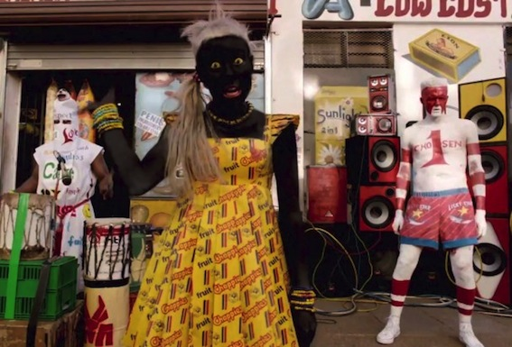
There are also clips of white Afrikaners dressed in blackface in the “I Fink U Freaky,” and “Banana Brain” videos. Yet, it is the fact that Die Antwoord’s use of blackface is not utilized in a way that conveys a clear, direct social or political message that makes it horribly, completely problematic. In comparison, members of the punk movement often utilized the Swastika symbol on their clothing, but for a highly specific reason: to emphasize that the Swastika was just a symbol, and without its context of hate and evil, it is devoid of significance. As Hebdige claims:

“The signifier (swastika) had been willfully detached from the concept (Nazism) it conventionally signified, and although it had been repositioned (as ‘Berlin’) within an alternative subcultural context, its primary value and appeal derived precisely from its lack of meaning: from its potential for deceit” (1265).

Die Antwoord makes no attempt at using blackface to create social commentary—instead, it appears that it uses it simply because it will inevitably astound and shock viewers; the group is therefore promoting racist practices simply for the sake of entertainment, a practice that by now should have been buried deep in the past.
Klopper notes that “in South Africa, Die Antwoord has also repeatedly been accused of being ‘basically blackface,’ because of its appropriation of the distinctive gangster style rap of the ‘Coloured’ musicians of mixed-race origins who live in poverty-stricken communities on the Cape Flats, close to the heartland of tourist-friendly Cape Town.” Ninja’s explanation for this, while superficially logical, remains flawed:
“We like to absorb all the different elements of South Africa that we find interesting and attractive and unique. We're like sponges. There's things about the Xhosa culture that we love, and we love things about the Afrikaans culture; that's very amusing and interesting to us. And then there's the colored culture, which is a whole other thing. The PC-version people try and promote this image of South Africa as a rainbow nation and make it all like pretty and stuff. But it's actually like this fokked-up, kind of broken fruit salad. ‘Cause all those things don't mix that well together in the real world. But for us it does mix. That's why we say it's, like, ‘fokked into one person.’ ‘Cause that's how we feel on a certain level. Like we absorb all these things, but they're not harmoniously flowing together through the air in this pretty rainbow picture.” (Mechanic).

Thus, taking Klopper’s argument a step further, I conclude that Die Antwoord’s use of blackface and claim that its mixing of all types of South African culture into Zef appropriates and muddies ‘subculture’ in a destructive way, and in many ways white-washes all South African cultures as it brings them under the white Afrikaner umbrella from which Zef originates. In the band’s success, it sets forth the example that white-washing music and frivolously using racist symbols are acceptable practices in the music industry, and ones to be admired as they real in popularity for the artist. Considering Hebdige’s claim of “distinction between originals and hangers-on,” that “is always a significant one in subculture,” it can be argued that Die Antwoord, instead of being the face of Zef subculture, is a mere ‘hanger-on’ to the movement that never truly delves into Zef’s subcultural significance (1266). In the song “Happy Go Sucky Fucky,” ¥o-landi screams, “Fuck your rules, fuck fuck your rules!” While this embodies “the idea of style as a form of refusal,” it remains unclear to what Die Antwoord is refusing, and why it is refusing it; the entire persona of Die Antwoord—the clothes, the bizarre and eccentric interpretations of sexuality, the cinematography in its videos all appear devoid of subcultural meaning.
As Hebdige concludes, a subculture must identify “the status and meaning of revolt, the idea of style as a form of Refusal, [and] the elevation of crime into art” (1258). Thus, in order to be deemed a subculture, Die Antwoord must do all three. While Die Antwoord has demonstrated its ability to utilize “the idea of style as a form of Refusal,” in its rebellious lyrics and dismissal of authority in favor of sexual deviance in many of its music videos, as well as an “elevation of crime into art” with its many displays of graffiti, and its use of violence in “Fatty Boom Boom,” Die Antwoord fails to demonstrate subcultural meaning in its revolt (1258). The band does not seek to promote a particular sociopolitical message in its work, or to gather its fan base around one clear, common theme. While Die Antwoord has developed a clear fashion style and a cohesive aesthetic for its music videos, its inclusion of marketable products in its media, such as Dr. Dre Beats headphones and the many Pokémon paraphernalia placed within its videos consequently conveys a desire on the part of the group to sell products rather than a goal to inspire its audiences. In combination with its apolitical use of blackface and appropriation of the music and culture of many marginalized groups in South Africa, Die Antwoord has ultimately failed to fulfill Hebdige’s definition of subculture.

Works Cited

“Baby’s On Fire.” YouTube, uploaded by Die Antwoord, 5 June 2012,
https://www.youtube.com/watch?v=HcXNPI-IPPM.

“Banana Brain.” YouTube, uploaded by Die Antwoord, 31 Aug. 2016.
https://www.youtube.com/watch?v=XXlZfc1TrD0.

Click, Melissa A., Hyunji Lee, and Holly Willson Holladay. "Making Monsters: Lady Gaga, Fan
Identification, and Social Media." Popular Music and Society 36.3 (2013): 360-79. Taylor & Francis. Web. 18 Dec. 2016.

Climent, James, Kenneth L. Hill, David Macmichael, and Carl Skutsch. "South Africa: Anti-
Apartheid Struggle, 1948-1994." Encyclopedia of Conflicts Since World War II. Vol. 1. N.p.: n.p., n.d. 1156. Print.

“Cookie Thumper.” YouTube, uploaded by Илья qwert, 9 Feb. 2015,
https://www.youtube.com/watch?v=qyGIMvHY1WA.

Die Antwoord. “Happy Go Sucky Fucky.” Donker Mag, Zef Recordz, 2014, Spotify.

“Die Antwoord Extended Uncut Interview.” YouTube, uploaded by Damien Lay, 23 Jan. 2011,
https://www.youtube.com/watch?v=TBpi-mv6qX8.

“Die Antwoord/ Yolandi Visser Style.” Polyvore.com.
http://www.polyvore.com/die_antwoord_yolandi_visser_style/collection?id=4405436.

Edwards, Jess. “Lady Gaga’s meat dress looks pretty bleak now,” Cosmopolitan, 3 Sept. 2015.
http://www.cosmopolitan.com/uk/fashion/celebrity/news/a38329/lady-gagas-meat-dress-what-looks-like-now-photos/.

“Enter The Ninja.” YouTube, uploaded by DieAntwoordVEVO, 3 Aug. 2010,
https://www.youtube.com/watch?v=cegdR0GiJl4.

“Fatty Boom Boom.” YouTube, uploaded by Noisey, 16 Oct. 2012,
https://www.youtube.com/watch?v=AIXUgtNC4Kc.

Hebdige, Dick. “Subculture: The Meaning of Style.” Literary Theory: An Anthology,
edited by Julie Rivkin and Michael Ryan, Blackwell Publishing, 2004, pp. 1258-1267.

Hoby, Hermione. “Die Antwoord: ‘Are we awful or the best thing in the universe?,” The
Guardian, 11 Sept. 2010.
https://www.theguardian.com/music/2010/sep/12/die-antwoord-music-feature.

“I Fink U Freaky.” YouTube, uploaded by Die Antwoord, 31 Jan. 2012,
https://www.youtube.com/watch?v=8Uee_mcxvrw.

Klopper, Sarah. "Art and culture in contemporary South Africa." Thesis Eleven 115.1 (2013):
127-40. Sage. Web. 18 Dec. 2016.

Krueger, Anton. "Zef/ Poor White Kitsch Chique: South African Comedies of Degradation."
(n.d.): n.p. Web. 18 Dec. 2016.

Mechanic, Michael. “Die Antwoord on Cultural Overload, Evil Boy, and the Meaning of Zef.” Mother Jones, 11

Oct. 2010. http://www.motherjones.com/riff/2010/10/die-antwoord-ninja-evil-boy-interview.

Kitching, Audrey. “Style Icon: Yolandi Visser of Die Antwoord,” Buzznet.com, 25 Aug. 2012.
http://www.buzznet.com/2012/06/style-icon-yolandi-visser-die/style-icon-yolandi-visser-of-die-antwoord-12/.

Van Der Merwe, Schalk D. ‘“Radio Apartheid’: Investigating a History of Compiance and
Resistance in Popular Afrikaans Music, 1956-1979.” South African Historical Journal, 66.2 (2014): 349-70. Web. 29 Mar. 2017.

.

Die Antwoord and friends posing with a modern-day Ford Zephyr. Their Zef logo can be seen in the lower right corner (Dieantwoord.com).
Examples of Die Antwoord’s ‘style’ (Kitching; Polyvore.com).
Strange performances of sexuality in Die Antwoord’s “I Fink U Freaky” music video (Die Antwoord “I Fink U Freaky,” Youtube.com).
Die Antwoord’s parody of Lady Gaga’s “Meat Dress,” left (Die Antwoord “Fatty Boom Boom”). Lady Gaga at the 2010 MTV Music Awards, right (Edwards).
Viewing statistics as of December 19th, 2016.
¥o-landi Vi$$er in blackface in “Fatty Boom Boom” (Die Antwoord, Youtube.com).

